JOY OF COMPUTING USING PYTHON

Experiment-1

Date:17/08/2018

Objective:Write a program to print all the divisors of a given number

Code:

def get_divisors(num):

result = [(1, num)]

for i in range(2, int(num**0.5+1)):

if num % i == 0:

result.append((i, int(num/i)))

print_divisor(result)

def print_divisor(result):

print("Divisor(s) of", result[0][1], " := ")

for a, b in result:

print(a, "*", b)

get_divisors(20)

get_divisors(50)

get_divisors(100)

Output :

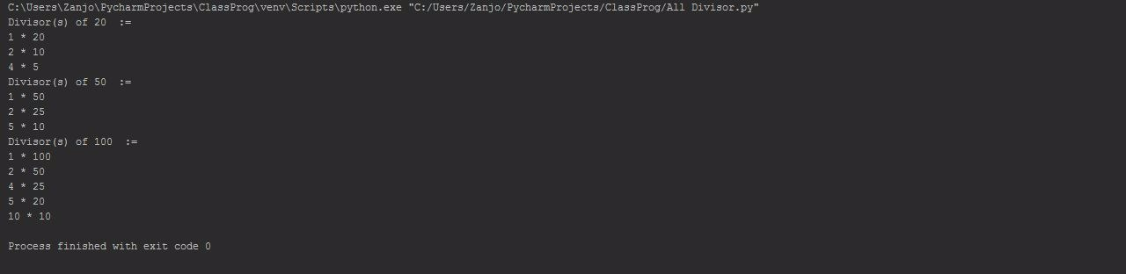

Experiment-2

Objective:Write a program to print the smallest divisor of a number

Code:

def smallest_divisor(num):

print("Smallest divisor of", num, "is ", end="")

for i in range(2, int(num**0.5+1)):

if num % i == 0:

return i

print(smallest_divisor(20))

print(smallest_divisor(77))

print(smallest_divisor(39))

OUTPUT:

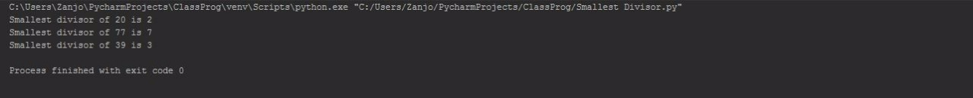

Experiment-3

Objective:Write a program to print the largest integer in a list.

Code:

def find_max(given_list):

print("Largest Integer in", given_list, "is ", end="")

max = given_list[0]

for i in range(1,len(given_list)):

if given_list[i] > max:

max = given_list[i]

return max

print(find_max([9, 1, 6, 3, 4, 8, 3, 3, 3, 3]))

print(find_max([2, 3, 0, 5, 2, 1, 6, 1, 7, 3]))

OUTPUT:

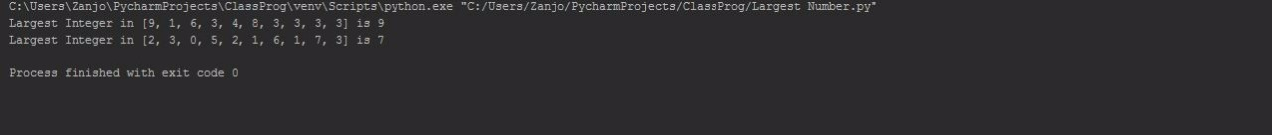

Experiment-4

Objective:Write a program to find the average of given numbers in a list.

Code:

import functools

find_avg = lambda l : functools.reduce(lambda x,y:x+y, l) / len(l)

my_list = [1,2,3,4,5]

print("Average of",my_list,"is",int(find_avg(my_list)))

my_list = [6,7,8,9,10]

print("Average of",my_list,"is",int(find_avg(my_list)))

OUTPUT:



Experiment-5

Objective:Write a program to give the longer string.

Code:

def find_length(string):

counter = 0

for i in string:

counter += 1

return counter

s1 = "Small"

s2 = "Bigger"

print(s1 if find_length(s1)>find_length(s2) else s2, "is the Longer String")

s1 = "Agnibha"

s2 = "Zanjo"

print(s1 if find_length(s1)>find_length(s2) else s2, "is the Longer String")

OUTPUT:

